Using Three Dice Take for Math Fact Fluency:
- Purpose: Derived Fact Strategy for Multiplication and Division
- Purposeful, frequent practice is needed for students to develop the fluency to progress to Phase 3 with all multiplication facts
- The key is to make practice through games as meaningful and strategy focused as possible.
About Games and Math Fact Fluency:
Games are fun. But, more importantly, games are effective ways to support learning. Games provide opportunities for:
- low-stress practice of (1) facts and (2) strategies (both outcomes are critical to math beyond the basic facts!).
- think aloud, an effective learning strategy. Therefore, students should develop the habit of verbalizing their mathematical thinking out loud.
- student listening and learning from peers. Therefore, discussing strategies before and after playing allows students opportunities to learn from each other.
- teachers to formatively assess and plan instruction. Therefore, at times, use an observation tool to record how students are progressing.
Effective math fact fluency games remove time pressure and allow students time to think. That means no time component. Each player has their own cards or dice to roll, so they are not racing each other. Scoring is de-emphasized. Thinking strategies are front and center.

Three Dice Take 2 players
Materials: three dice, counters in two different colors (20 of each) or two colors of markers (if game board is laminated), game board numbered 0-39 (see student game board)

0 | 1 | 2 | 3 | 4 | 5 | 6 | 7
8 | 9 | 10 | 11 | 12 | 13 | 14 | 15
16 | 17 | 18 | 19 | 20 | 21 | 22 | 23
24 | 25 | 26 | 27 | 28 | 29 | 30 | 31
32 | 33 | 34 | 35 | 36 | 37 | 38 | 39

Three Dice Take 2 players
How to Play:
- Player 1 rolls all three dice.
- Use all three numbers with any combination of operations to get a number on the game board.
- Cover that number with your marker.
- Record 1 point for the number you covered and an additional point for each marked box that touches your number.
- Repeat all steps for Player 2.

Game in Action: Player 1 rolls a 3, 4, and 6 on the dice. The player strategically looks at the board to determine a target number. The number on the board the player wishes to cover is 18. The player uses 3 x 4 + 6 = 18 as the equation. The player then scores 1 point for covering the target number and 1 point for each of the covered boxes that touches the number. In the example below, the player scores additional points for boxes 10, 11, 19 and 26 because they touch 18.
I rolled a 3, 4, and 6 on my dice. My equation is 3 x 4 + 6 = 18. I score a point for covering the 18. Because my 18 is touching, 10, 11, 19, and 26 which are taken/marked boxes, I get 4 more points. My total score is 5 points. Bummer, I can’t get an extra point for 12 even though it is a taken/marked box. It is not touching my 18. Double bummer! The number 27 is not a taken/marked box! I can’t score a point for that box either.

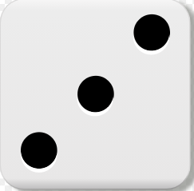

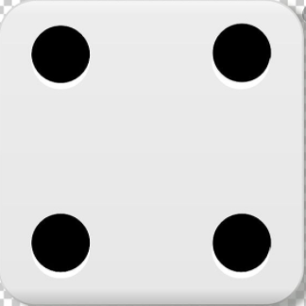

Player 1 |  | Player 2
Equation | Points | Equation | Points
3 x 4 + 6 = 18 | 5 points

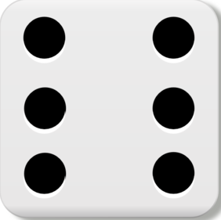

10 | 11 | 12
18 | 19 | 20
26 | 27 | 28

Possible Variations:
- Mark six to eight spaces before player make their first move to jump start the strategic selection of spaces.
- Pair students into teams and play two teams per game board. This promotes mathematical discussion between partners.

